1. ​Write a function to compute 5/0 and use try/except to catch the exceptions.

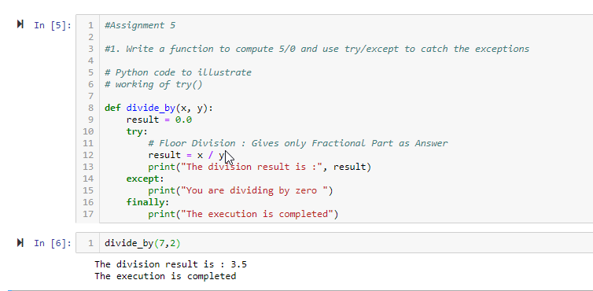

#1. Write a function to compute 5/0 and use try/except to catch the exceptions

# Python code to illustrate

# working of try()

def divide_by(x, y):

result = 0.0

try:

# Floor Division : Gives only Fractional Part as Answer

result = x / y

print("The division result is :", result)

except:

print("You are dividing by zero ")

finally:

print("The execution is completed")

divide_by(7,2)

2. ​Implement a Python program to generate all sentences where subject is in ["Americans", "Indians"] and verb is in ["Play", "watch"] and the object is in ["Baseball","cricket"].

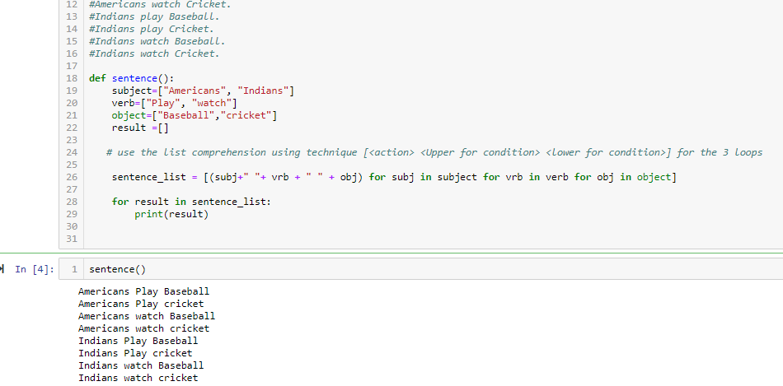

#2. Implement a Python program to generate all sentences where subject is in ["Americans","Indians"] and

#verb is in ["Play", "watch"] and the object is in ["Baseball","cricket"]

#Hint: Subject,Verb and Object should be declared in the program as shown below.

#subjects=["Americans ","Indians"]

#verbs=["play","watch"]

#objects=["Baseball","Cricket"]

#Output should come as below:

#Americans play Baseball.

#Americans play Cricket.

#Americans watch Baseball.

#Americans watch Cricket.

#Indians play Baseball.

#Indians play Cricket.

#Indians watch Baseball.

#Indians watch Cricket.

def sentence():

subject=["Americans", "Indians"]

verb=["Play", "watch"]

object=["Baseball","cricket"]

result =[]

# use the list comprehension using technique [<action> <Upper for condition> <lower for condition>] for the 3 loops

sentence_list = [(subj+" "+ vrb + " " + obj) for subj in subject for vrb in verb for obj in object]

for result in sentence_list:

print(result)